First Graders Learn About Low Vision

On March 14, 2016 Partners for Pediatric Vision hosted a Low Vision Day for 49 first graders from John Thomas Dye School. For ten years, Partners in Pediatric vision has provided a simulated experience for the first graders to help them experience what it might be like to have a visual impairment. Masks are made for each child that simulate visual conditions that children and adults may experience from diagnoses such as retinal detachments, glaucoma, cataracts, or optic nerve damage. When the children wear their masks, they go from fully sighted to partially sighted and must navigate the stations with tunnel vision or visual field loss, blurred or reduced vision. At the “Eye-Mazing” station, students learn from a Pediatric Optometrist what happens at a low vision exam. At “ Be My Guide” they meet working guide dogs and the adults who depend on them in order to travel safely around any environment. “Cool Tools” is where the first graders try out low vision aids like magnifiers, telescopes and a light box that encourages visual learning and play with babies and young children. Students learn all about why and how children and adults use a white cane and learn sighted guide techniques while “On the Move.” “Technology is Terrific” is where the first graders learn about CCTV’s, which magnify print, and low vision technology that is available to people with visual impairment in order to succeed in school and work. This year, the John Thomas Dye first graders turned plastic water bottles into fun visual and auditory rattles filled with bells, mylar strips, beads and ribbon that can be rolled or shaken to attract the visual attention of our young patients. All of the rattles from our “Shake, Rattle and Roll” station are donated to families of children who receive services from Partners for Pediatric Vision in order to encourage visual attention and tracking, reaching, grasping, crawling, shaking, rolling and much more.

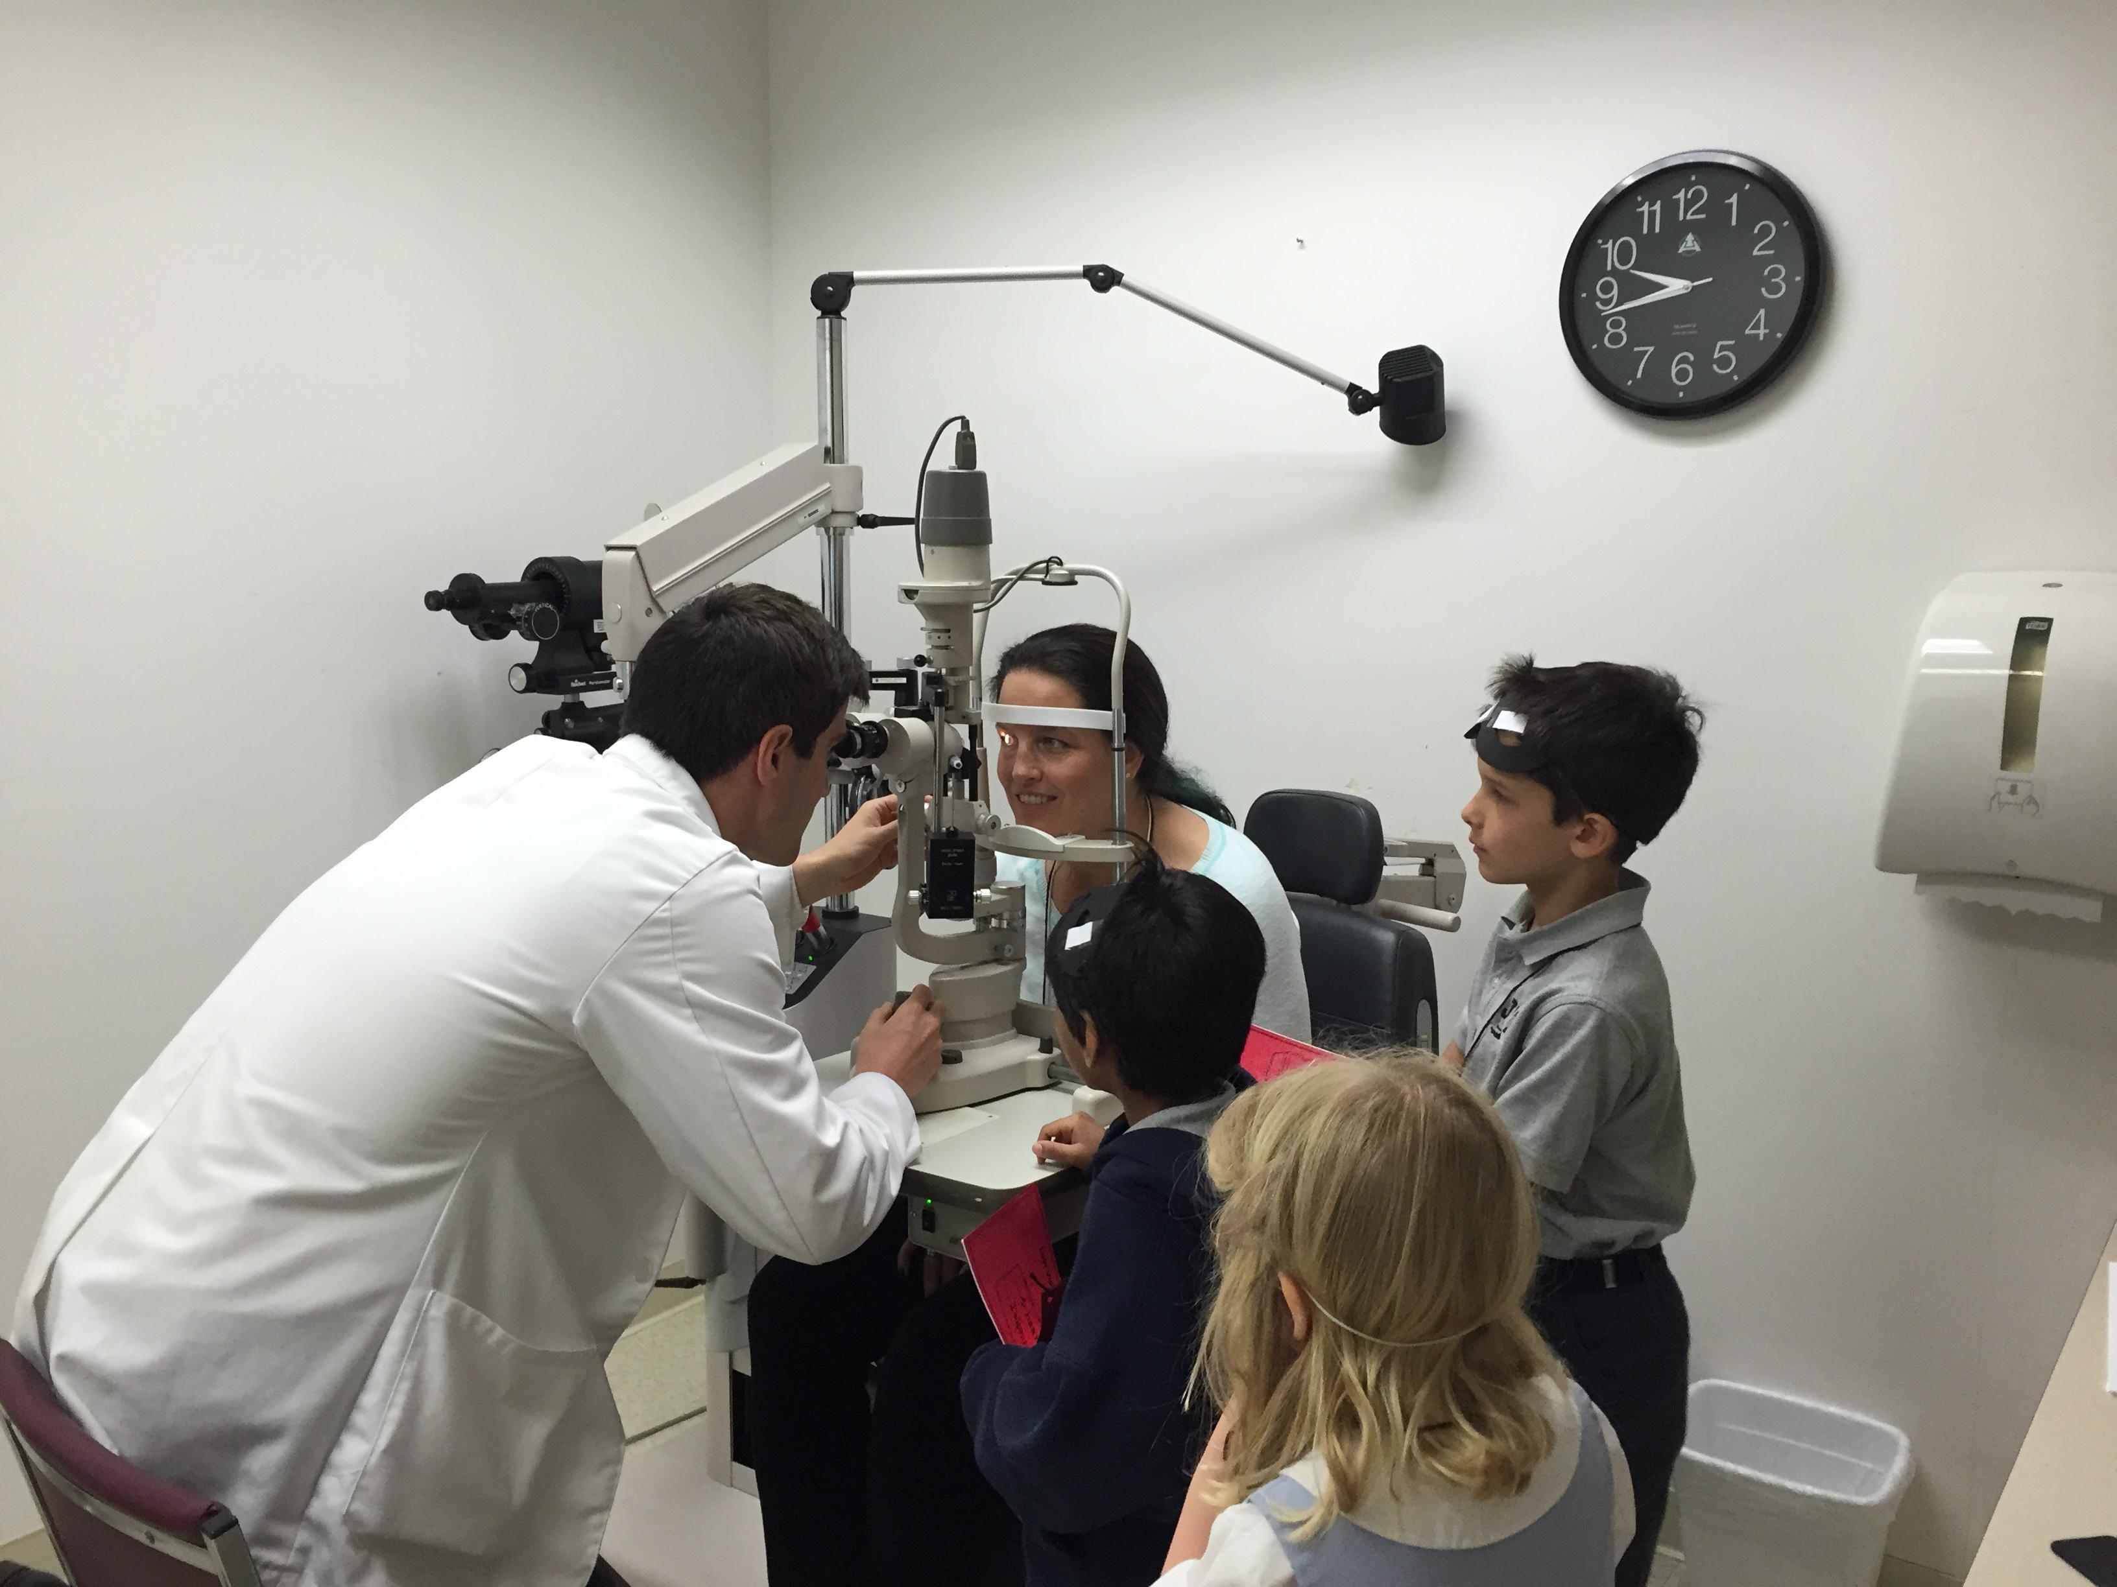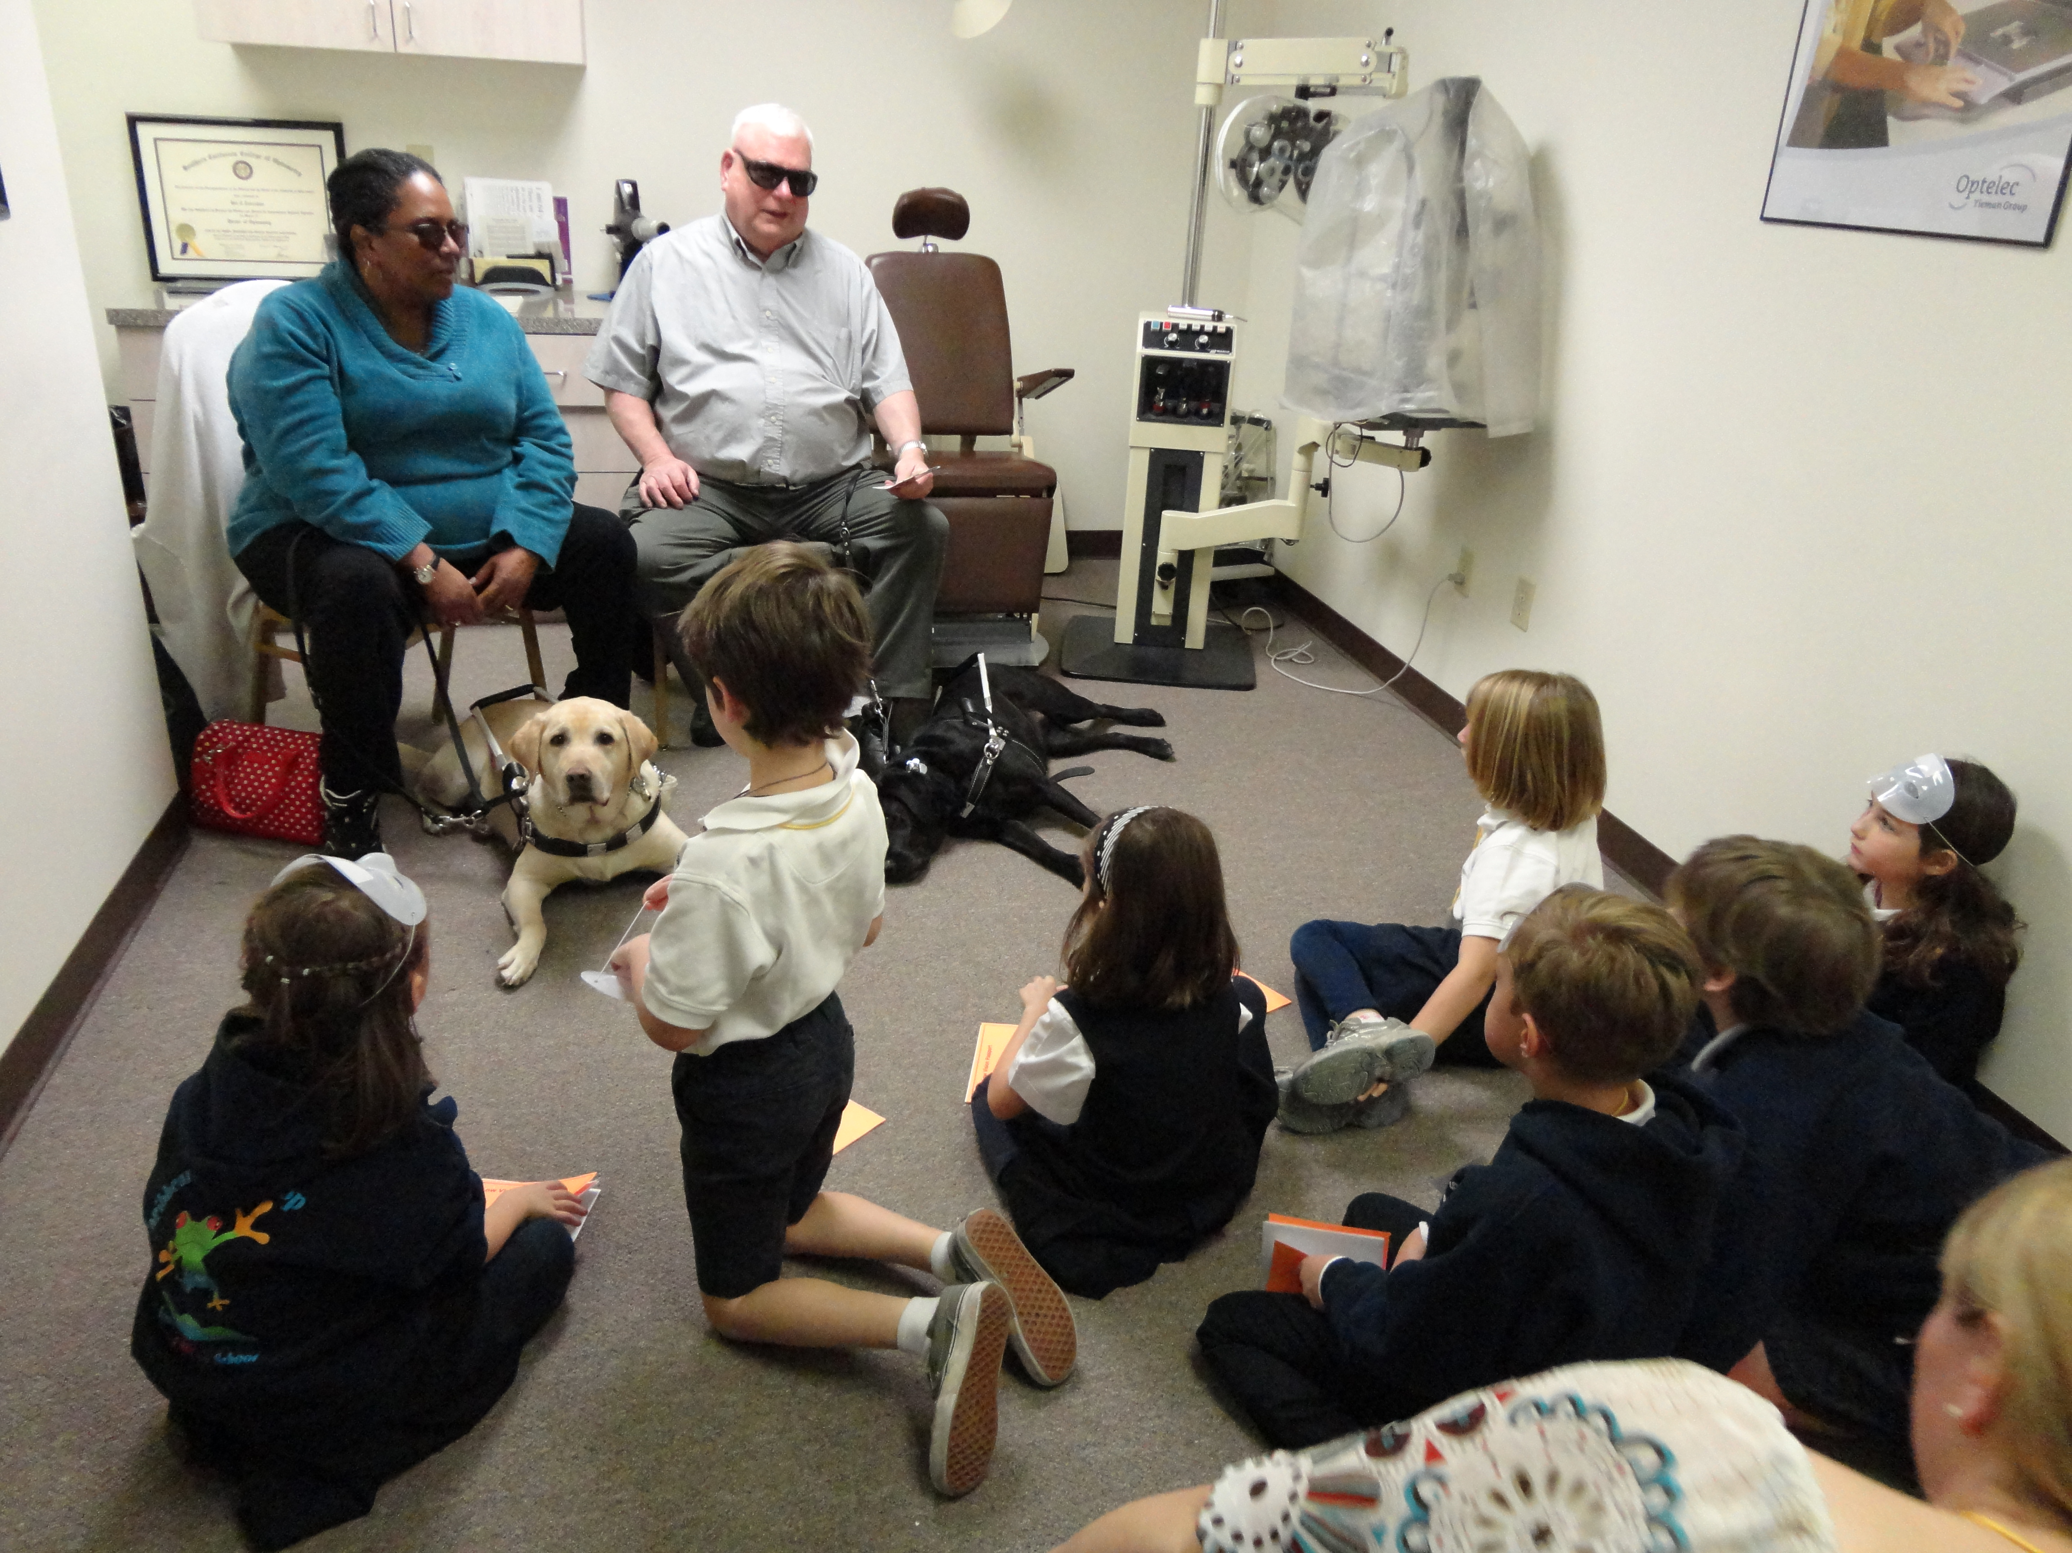
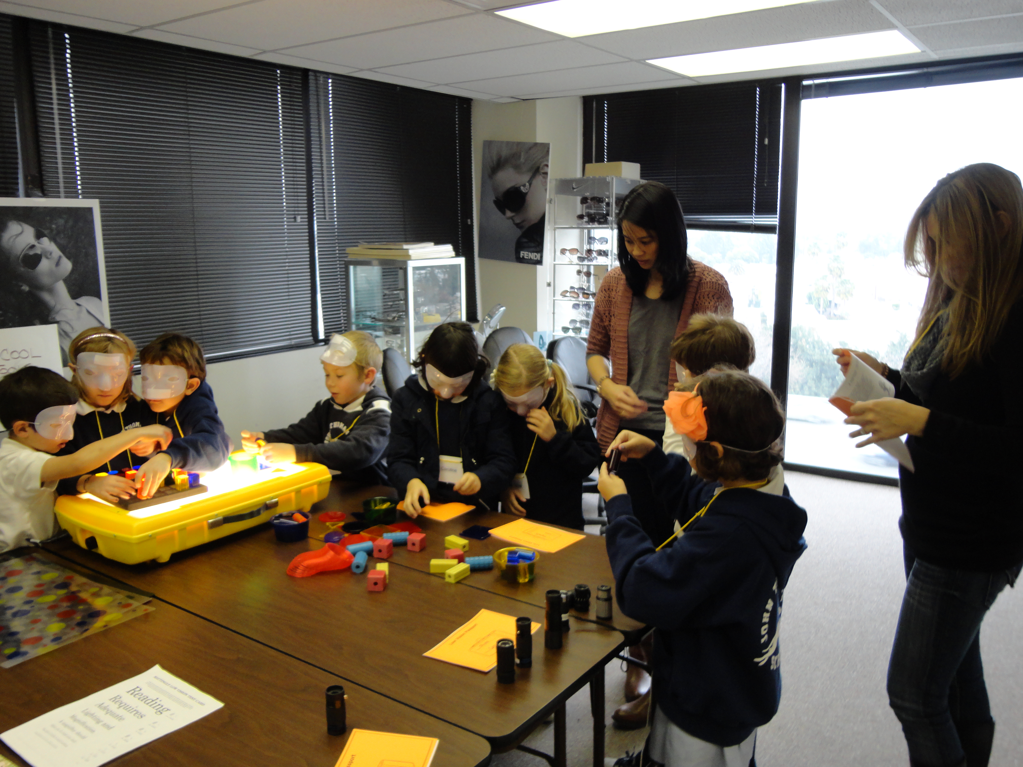
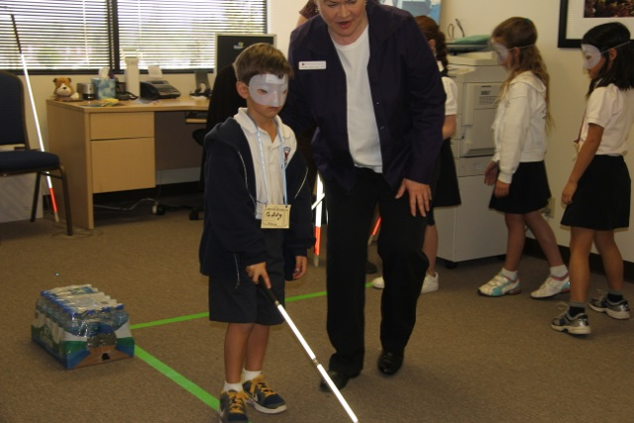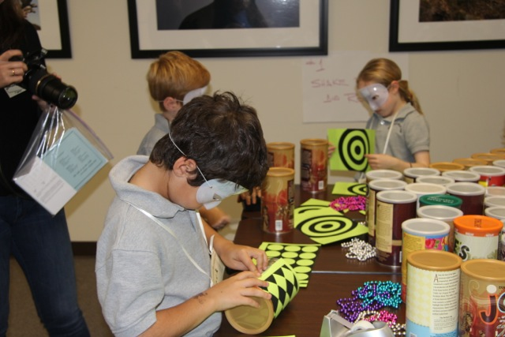
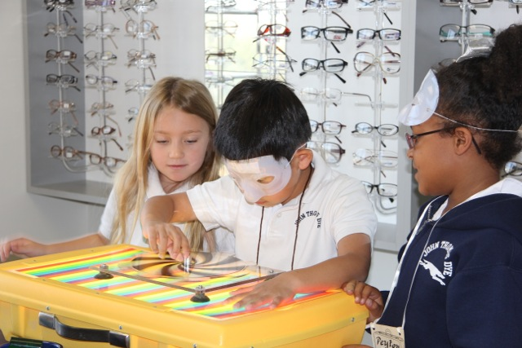

This relationship between Partners for Pediatric Vision and John Thomas Dye School not only benefits the first graders and many of their parents who come along, the program benefits in an important way as well. The first graders and their families raise money for a special fund that helps families of children pay for glasses or magnifiers when they cannot afford them. Being fitted with glasses at an early age makes a life changing difference for many children who may begin to smile or reach out, crawl or walk as a result of being able to see the world more clearly. Magnifiers may make the difference for children struggling to identify letters or read. Many children and their families have benefitted from the generosity of the first grade classes at John Thomas Dye and we always look forward to hosting them for our Low Vision Day. This year, Low Vision Day will be on March 2nd, 2017.

Isabel received glasses with the help of the John Thomas Dye fund.
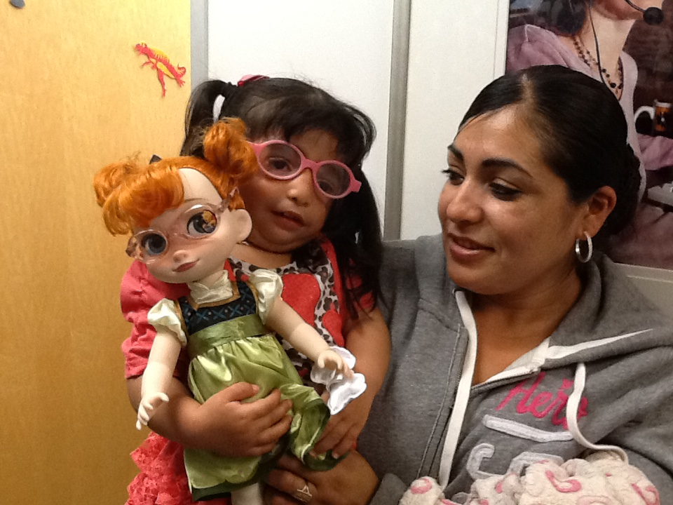

Here are some journal entries from the kids – not sure if we can cut out the Center for the Partially Sighted on any of them ? and just highlight a few comments and the drawings

